Deep learning based visibility analysis for cosmetic advertisement
Kartik Gorde¹, Anuradha Karule¹, Sharwari Mondhe¹, Shlok Patel¹*
¹Department of Information Technology,
Sipna College of Engineering and Technology (SCOET),
Sant Gadge Baba Amravati University (SGBAU), Amravati, India
Emails: kartikgorde04@gmail.com, anuradhakarule0@gmail.com,
sharwari774@gmail.com, shlokpatel0550@gmail.com*
Phone: +91-7020338771
ORCID:
Kartik Gorde – 0009-0009-5787-1169
Anuradha Karule – 0009-0001-9953-543X
Sharwari Mondhe – 0009-0009-8762-4337
Shlok Patel – 0009-0002-0258-3660

Abstract— The increasing need for systems that automatically assess product and brand visibility arose from the fast expansion of digital advertising. The traditional methods for advertisement evaluation need to depend on manual checks together with user inputs which create problems because these methods require long time periods and produce subjective results that are hard to expand. This paper presents a deep learning–based framework for visibility analysis of cosmetic advertisements. The system uses YOLOv8 technology to detect cosmetic products together with a visual saliency model that predicts human visual attention and PaddleOCR technology which extracts and assesses textual elements like brand names and promotional material. The system uses object localization together with attention maps in order to generate visible metrics which include an attention-based visibility score and a distraction rate. The evaluation process uses a custom cosmetic dataset which contains more than 10000 annotated advertisement images. The experimental results show strong detection and visibility performance which achieved an mAP@0.5 of 0.908 for cosmetic products. The results validate that the proposed framework works effectively for cosmetic advertisement visibility assessment which needs both scalability and objective assessment.

Keywords— YOLOv8, visual saliency, advertisement visibility, object detection, OCR, deep learning
- INTRODUCTION
Digital advertising has emerged as the main channel through which brands communicate their messages and market their products on internet platforms and social media networks. Cosmetic advertisements use visual elements which include product packaging and brand logos and container design and promotional text to create effective methods of drawing customer interest to their products. Accurate analysis of product visibility is therefore essential for advertisers and designers to evaluate advertisement effectiveness and ensure compliance with visual presentation standards [1], [11].

The traditional methods which advertisers use to assess their advertisement performance use manual visual inspection and expert judgment together with consumer-based studies which include surveys and eye-tracking experiments. The methods provide useful information but they require a lot of time and money and they produce results which depend on personal judgment which makes them unsuitable for analyzing digital advertisements on a large scale and in real time [2], [4]. The differences in how people see things lead to different results when evaluating how important products appear and how strong visual elements show their importance in advertisements.
The development of deep learning and computer vision technology has enabled automated systems to achieve high accuracy when performing visual content analysis. Convolutional Neural Networks (CNNs) have demonstrated strong performance in object detection and visual recognition tasks, making them effective for identifying products and brand elements in advertisement images [3], [5], [15]. Visual saliency models have been developed to estimate human visual attention by predicting regions likely to attract viewer focus [4], while Optical Character Recognition (OCR) methods enable the extraction and analysis of textual components which include brand names and promotional content [6]. The advancements in technology create a requirement for a unified system, which assesses product visibility together with the assessment of visual elements.
- Related Work

The current research studies automated advertisement evaluation through its three components of object detection, visual saliency estimation, and text extraction which researchers study as separate systems. The commercial images and videos use real-time object detection frameworks which include YOLO because of their ability to quickly and precisely identify products and logos [1], [3], [5]. The method of object detection does not provide information about the amount of viewer attention which detected products receive.

Visual saliency prediction models estimate human attention through their ability to identify regions which will most likely attract visual focus. The early feature-based methods depended on basic visual elements, but the current deep learning methods achieve better results at estimating attention in intricate visual environments [4], [11]. Saliency-based methods have demonstrated potential for evaluating product placement effectiveness, but they often lack explicit object-level visibility metrics and operate independently of detection systems.

The OCR-based methods have been used to extract brand names and promotional text from advertisements which supports the evaluation of text clarity and placement [6]. The YOLO-based models can perform appearance analysis and skin-related visual analysis because they successfully extract detailed visual information which connects to cosmetic content [9], [10]. Research on small-object detection identifies three main challenges which occur in cosmetic advertisements: reflective surfaces and visually similar categories and limited object size [4], [7], [14]. The need for a unified framework arises because current detection systems and attention modeling and text analysis need to work together for effective visibility assessment of cosmetic advertisements.

Table 1 presents a comparative analysis of the proposed cosmetic advertisement visibility framework with existing approaches in advertisement analysis, product detection, and attention modeling. The proposed method develops a complete visibility assessment system through detection, saliency, and text extraction, which establishes a new research direction that different from previous studies, which examined these three components as separate entities.

Study / Approach | Target Domain | Object Detection | Visual Saliency | OCR / Text Analysis | Unified Visibility Metrics | Recommendation / Decision Support
Wang et al. (2024) | General Video Advertisements | No | Yes | No | No | No
Bruno et al. (2021) | Advertisement Layout Design | No | Yes | No | No | No
Hosseini et al. (2024) | Product Packaging / Branding | Yes (Logo-level) | Yes | No | Partial | No
OCR-based Detection Pipelines | Document / Structured Images | Yes | No | Yes | No | No
YOLO-based Product Detection Studies | Generic Object Detection | Yes | No | No | No | No
Proposed Framework (This Work) | Cosmetic Advertisements | Yes (Product-level) | Yes | Yes | Yes | Yes

Table 1. Comparative Analysis of Advertisement Visibility Analysis Approaches

- Methodology
The suggested framework delivers an automated system which evaluates cosmetic advertisement visibility through its three components of product detection and visual attention modeling and text readability assessment. The system processes advertisement images or video frames to identify cosmetic products, evaluate their visual prominence, and analyze associated textual content.

- Product Detection and Prominence Analysis

The core object detection model which automatically detects cosmetic products uses YOLOv8 to identify bottles and jars and lipsticks and tubes and pumps and all kinds of cosmetic packaging. The detector provides output information through which it shows bounding box coordinates and class names and detection confidence percentages for each identified object. The detection process proceeds to assess product prominence through spatial and geometric attributes of bounding boxes which include measuring the object's actual size and its frame positioning. This stage provides structured information regarding product presence and visual dominance.

- Saliency Model Analysis

The attention modeling module uses deep learning to create visual saliency maps which show pixel-based attention distribution through its visual saliency model. The model analyzes low-level visual cues such as color contrast and texture, as well as high-level semantic features, to identify regions likely to attract human attention. The generated saliency maps are aligned with detected product regions to determine whether products lie within high-attention areas of the advertisement.

- Attention-Based Visibility Score Computation

The detection process assigns visibility measurements to detected products through the combination of object localization data and visual attention information. The saliency heatmap for each detected product shows its attention score measurement through technological systems which restrict the heatmap to the relevant product bounding box area.

$\text{Attention Score}=\left(\frac{1}{N}\sum_{(i,j)∈B}{S_{i,j}}\right)×\frac{100}{255}$ (1)
where,
B represents the bounding box region, $S_{i,j}$ denotes saliency intensity, and 𝑁 is the number of pixels within the bounding box.

To capture overall advertisement visibility, frame-level attention scores are aggregated across all frames in which the product is detected:

$\text{Visibility Score}=\frac{1}{N}\sum_{t=1}^{N}{A_{t}}$ (2)
The distraction rate is computed to identify cases where a product is present but fails to attract attention:

$\text{Distraction Rate}=\left(\frac{\text{Number of Distracted Frames}}{\text{Total Frames with Detection}}\right)×100$ (3)
- Text Readability Analysis and LLM Integration

PaddleOCR enables users to identify and retrieve text elements which include brand names and advertising content from their advertisement pictures. Product text visibility assessment uses three factors which are font size and contrast and product spatial alignment. The visibility metrics which were obtained through extraction process, are processed by a Large Language Model (LLM) to create design recommendations, which explain design solutions and show potential visibility problems and enable compliance assessment.

- Overall Workflow of the Proposed Framework

The entire process of the suggested cosmetic advertisement visibility assessment system displays its operations through a series of steps that connect different deep learning elements. The system begins by taking advertisement images or video frames as input, which are first processed by the YOLOv8-based object detection module to localize cosmetic products and extract bounding box information. The system processes the same input through a visual saliency model to produce pixel-level attention heatmaps that show likely human visual focus areas.

The system computes attention-based visibility metrics by matching product regions which have been detected with their corresponding saliency maps. The system uses this alignment to measure the ability of each cosmetic product to draw viewer attention when the product exists in the frame. The OCR module extracts textual elements which include brand names and promotional messages while it assesses their readability according to visual clarity and spatial relationship with detected products.

The system calculates final visibility scores and distraction rates for each product by merging the results of product detection with attention modeling and text analysis. The system sends these structured metrics to a Large Language Model (LLM) which creates design insights and recommendations that can be easily understood. The complete system output provides quantitative visibility measurements together with marked visual representations and explanatory feedback which help to assess the effectiveness of cosmetic advertisements in an extensive and unbiased manner.

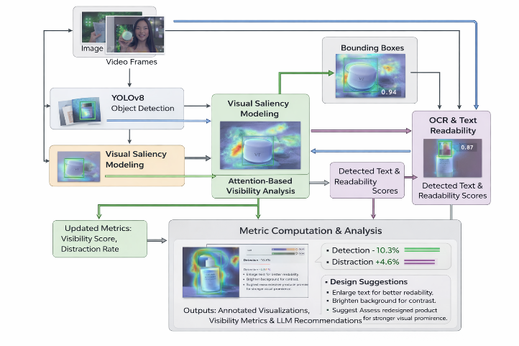
Fig. 1. Overall workflow of the proposed cosmetic advertisement visibility analysis framework.

- Dataset Description

The cosmetic dataset used in this study contains more than 10,000 annotated advertisement images which show different cosmetic packaging formats that people commonly use. The dataset includes different product characteristics, which include various product dimensions, product shapes, product colors, product placement angles, and the difficulty that different background elements present. The dataset contains YOLO format annotations together with three data partitions which include training data, validation data, and test data to support unbiased assessment. The class distribution analysis shows that object placement in the center of the image results in moderate balance between different classes of objects which matches actual patterns used in cosmetic advertisement design.

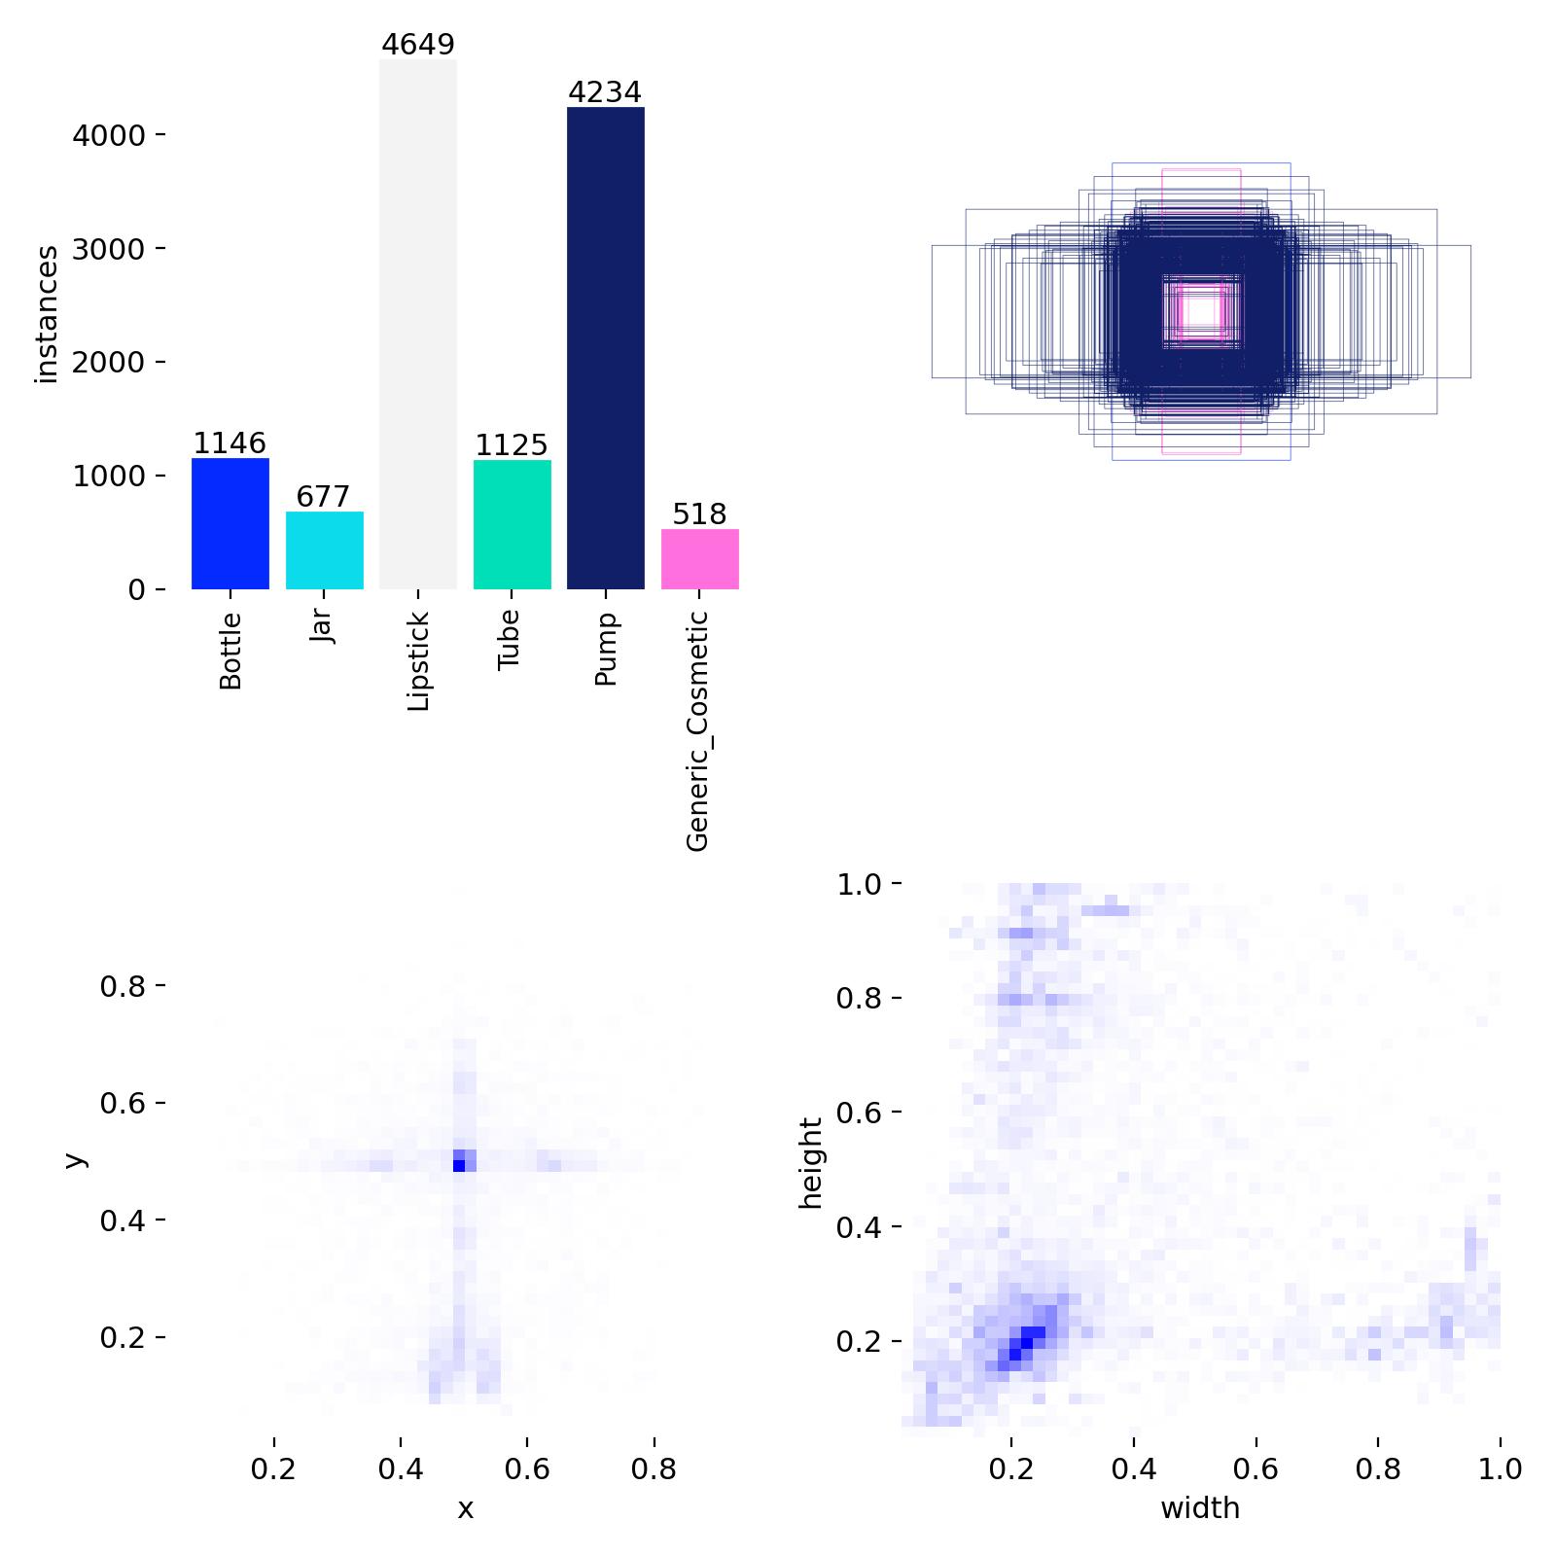

Fig. 2 Class distribution of cosmetic products in the dataset.
- Results and Discussion
  - Quantitative Performance Evaluation

The system evaluation of our proposed framework uses standard object detection metrics which include precision recall F1-score and mean Average Precision (mAP) as measurement metrics. Quantitative results demonstrate strong detection accuracy across cosmetic categories, with an overall mAP@0.5 of 0.908. The visual distinctive classes lipstick, jar, and bottle show high precision and recall performance, while the visually diverse category of generic cosmetic products displays lower performance results.

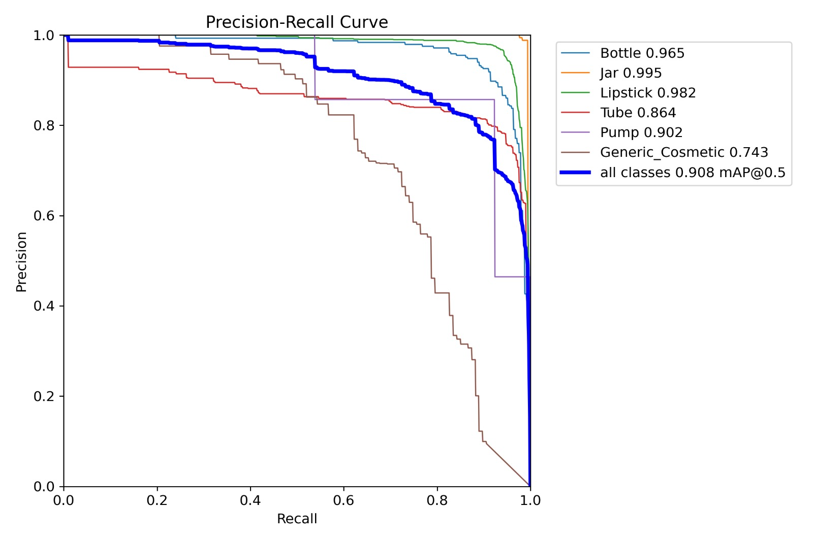
Fig. 3. Precision–Recall curves for cosmetic product detection.

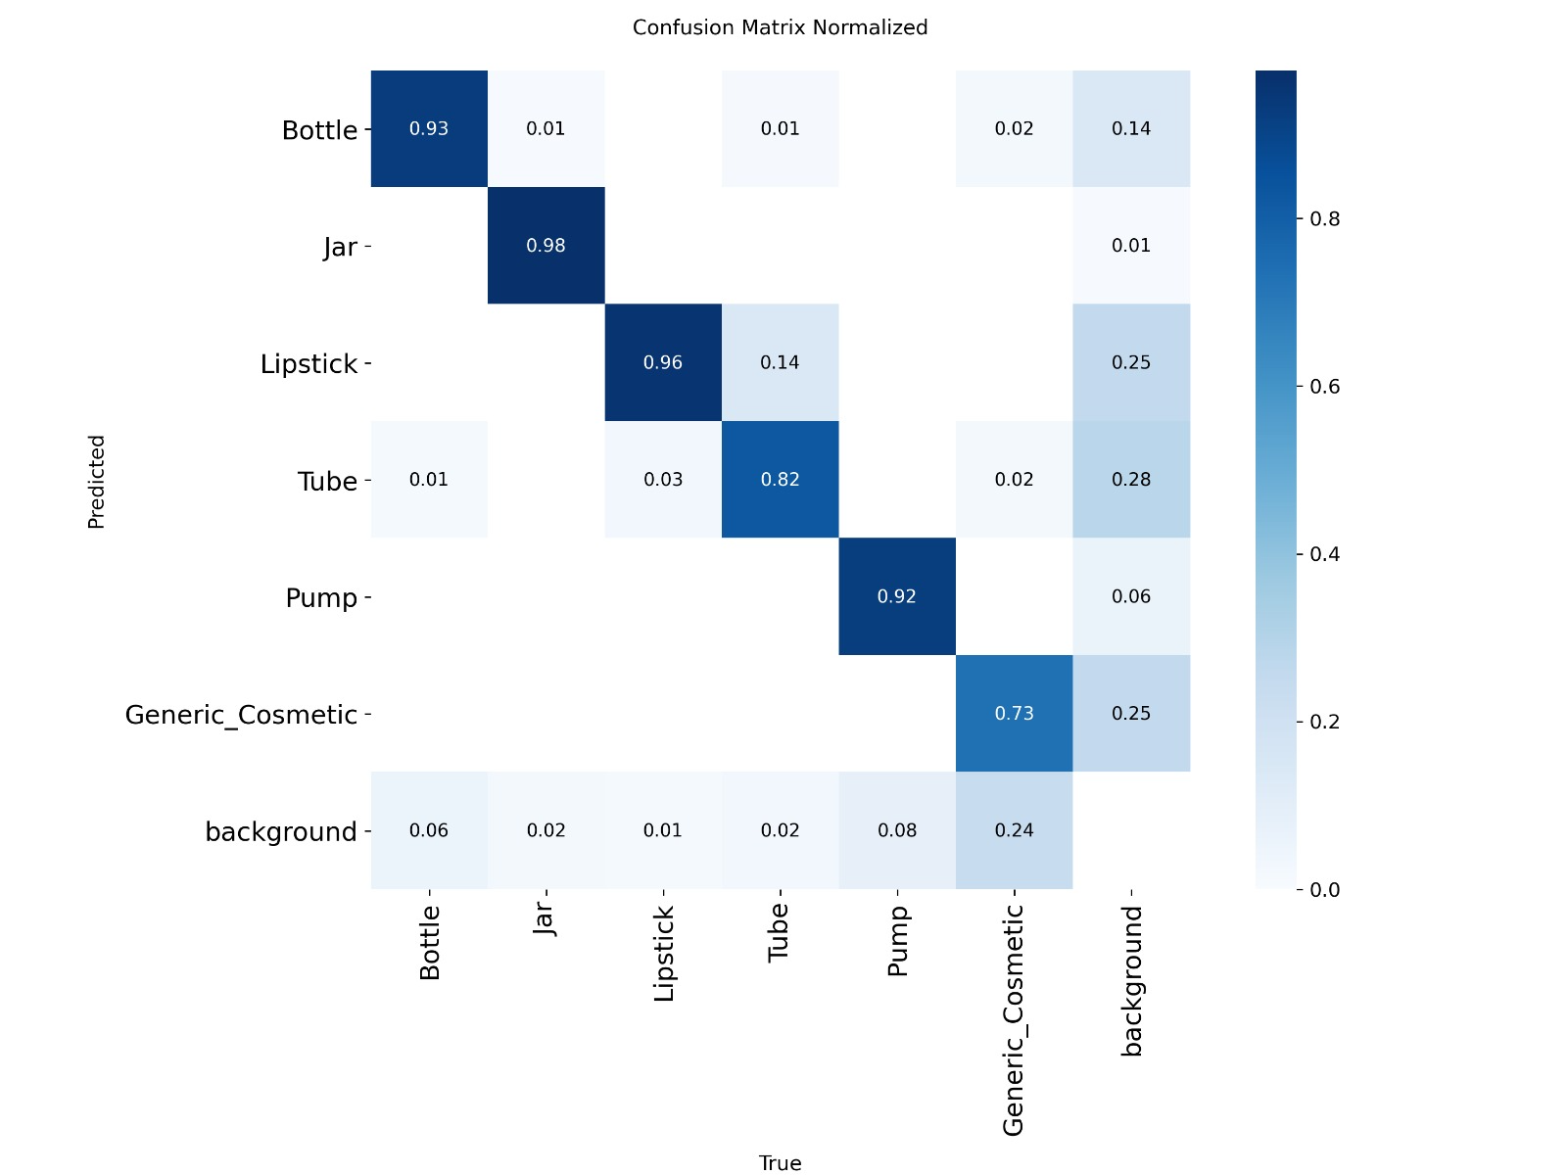

Fig. 4. Normalized confusion matrix for cosmetic product classes.

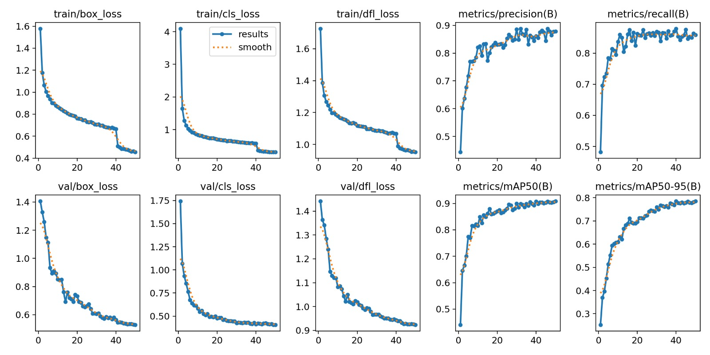

Fig. 5. Training and validation performance curves of the YOLOv8 model.

Confusion matrix analysis indicates reliable classification for most cosmetic categories, with misclassifications primarily occurring between visually similar packaging types. Qualitative analysis shows effective product localization with saliency peaks matching cosmetic products and successful extraction of brand-related text. The results show that our framework successfully combines detection capabilities with attention modeling and text analysis to perform automatic visibility assessment of cosmetic advertisements.

  - Qualitative Analysis

The assessment of product placement accuracy requires visual analysis to determine how well the proposed system achieves its goal of matching cosmetic product locations with areas that attract viewers. The YOLOv8-based detector successfully detects cosmetic products throughout various advertising settings which include hand-held products and influencer-style presentations and studio-based promotional layouts. The system achieves accurate product identification through its bounding box detection which succeeds in locating products despite existing background clutter and different lighting conditions.

The overlaid visual saliency heatmaps further indicate that regions corresponding to cosmetic products and brand labels consistently coincide with areas of high attention intensity. This alignment demonstrates that the attention-based visibility analysis system successfully measures viewer attention through its ability to track multiple objects in a scene. The advertising scenarios which feature product placement at the center and use color contrast and size to highlight products create stronger saliency responses which show that attention modeling serves as an important method for assessing product visibility.

The qualitative assessment demonstrates that the proposed framework maintains its effectiveness when it deals with packaging designs that share similar visual characteristics. The product detection system with saliency modeling delivers valuable visibility analysis through its ability to identify product detection and advertisement elements. The research findings demonstrate that the proposed method provides an accurate qualitative assessment of cosmetic advertisement visibility which occurs in actual environmental conditions.

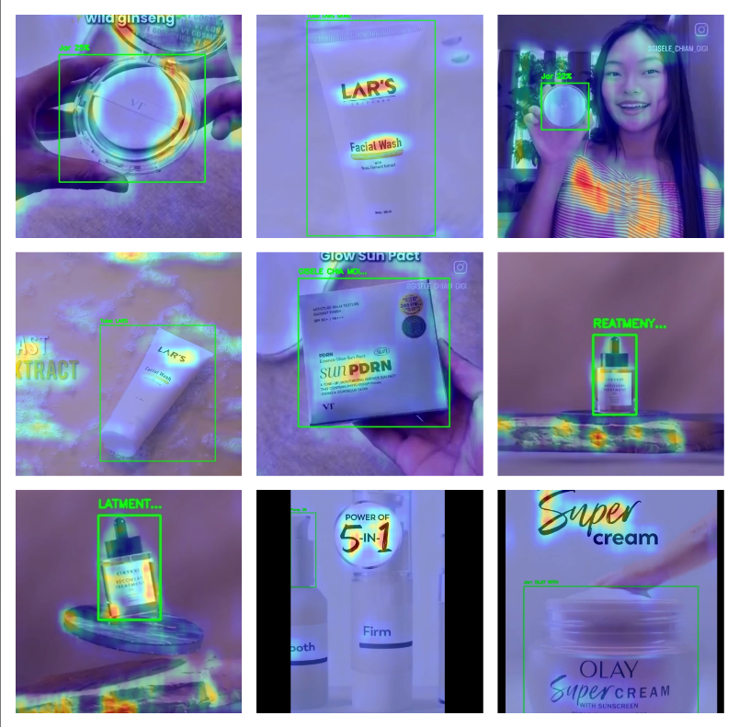

Fig. 6. Qualitative visualization of cosmetic product detection with saliency overlays.

  - Discussion

The experimental results demonstrate that the proposed framework achieves consistent performance across multiple cosmetic product categories. The detection accuracy improves for packaging types that exhibit distinct visual features because these features create more identifiable characteristics than the Generic_Cosmetic class which shows more common design elements. The class distribution analysis shows how dataset imbalance affects this behavior.

The qualitative visualizations confirm that the integration of visual saliency modeling with product detection enables effective identification of regions that are likely to attract viewer attention. The proposed approach combines three elements spatial localization, attention alignment, and text readability analysis to assess advertisement visibility in cosmetic advertisements more effectively than detection-based methods. The framework shows suitability for analyzing real-world cosmetic advertisements which use different layouts and presentation styles.
- Conclusion

The researchers developed a deep learning framework that uses deep learning methods to analyze visibility in cosmetic advertisements. The proposed system uses YOLOv8 product detection combined with visual saliency attention modeling and OCR text analysis to create an objective scalable method for assessing cosmetic advertising effectiveness. The scientific tests showed that the system achieved high detection accuracy together with dependable visibility measurements across different cosmetic product types. The framework demonstrates its ability to support practical uses in analyzing advertisement content and optimizing design and conducting visual inspection while creating a base for future studies about automatic evaluation of cosmetic advertisements.

references

- M. L. Ali and Z. Zhang, “The YOLO framework: A comprehensive review of evolution, applications, and benchmarks in object detection,” Computers, vol. 13, no. 12, p. 336, 2024.
- A. M. Hassan, R. K. Singh, and P. Kumar, “Performance analysis of deep learning-based object detection algorithms on the COCO benchmark,” Journal of Engineering and Applied Science, vol. 71, no. 76, pp. 1–15, 2024.
- S. Kang, Z. Hu, L. Liu, K. Zhang, and Z. Cao, “Object detection YOLO algorithms and their industrial applications: Overview and comparative analysis,” Electronics, vol. 14, no. 6, p. 1104, 2025.
- J. Novak, M. Petrovic, and A. Kovac, “Advancements in small-object detection (2023–2025): Approaches, datasets, benchmarks, and applications,” Applied Sciences, vol. 15, no. 22, p. 11882, 2025.
- D. Abhayankar, S. Tanwani, and D. K. Sharma, “Exploring object detection algorithms and implementation of YOLOv7 and YOLOv8-based models,” Int. J. Intelligent Systems and Applications in Engineering, vol. 12, no. 3, pp. 877–886, 2024.
- R. Mehta, P. Shah, and A. Kulkarni, “Comparative analysis of deep learning models for waste segregation using YOLOv8 and EfficientDet,” Multimedia Tools and Applications, vol. 84, pp. 35941–35964, 2025.
- Y. Li, H. Zhou, and J. Wang, “Leather defect detection based on an improved YOLOv8 model,” Applied Sciences, vol. 14, no. 24, p. 11566, 2024.
- A. Rahman and S. Putra, “Object detection using YOLOv8: A systematic review,” Sistemasi: Jurnal Sistem Informasi, vol. 14, no. 1, pp. 45–60, 2025.
- B. Inan, I. A. Ozkan, and N. Dogan, “Deep learning-based skin disease detection: Performance analysis of YOLOv8 and YOLOv11 models,” Int. J. Applied Methods in Electronics and Computers, vol. 13, no. 4, pp. 121–130, 2025.
- N. A. Dalawai, P. B. Prathamraj, B. S. Dayananda, A. P. Joythi, and R. Suresh, “Real-time skin disease detection and classification using YOLOv8 object detection,” Int. J. Multidisciplinary Research and Analysis, vol. 7, no. 12, pp. 210–218, 2024.
- L. Chen, W. Ouyang, X. Wang, and J. Zhou, “Development and challenges of object detection: A survey,” Neurocomputing, vol. 598, p. 128102, 2024.
- A. Wang, H. Chen, L. Liu, Z. Lin, J. Han, and G. Ding, “YOLOv10: Real-time end-to-end object detection,” arXiv preprint, arXiv:2405.14458, 2024.
- R. Khanam and M. Hussain, “YOLOv11: An overview of key architectural enhancements,” arXiv preprint, arXiv:2410.17725, 2024.
- A. Chandrashekhar, B. Satyanarayana, R. R. Gorrepati, and S. Rao, “An efficient YOLO-based framework for detecting extremely small-scale objects,” Scientific Reports, vol. 16, p. 2062, 2026.
- G. Jocher, A. Chaurasia, and J. Qiu, “Ultralytics YOLOv8: State-of-the-art real-time object detection,” Ultralytics White Paper, 2023.
- T.-Y. Lin, M. Maire, S. Belongie, et al., “Microsoft COCO: Common objects in context,” in Proc. Eur. Conf. Computer Vision (ECCV), 2014, pp. 740–755.
- X. Zhou, D. Wang, and P. Krähenbühl, “Objects as points,” arXiv preprint, arXiv:1904.07850, 2019.
- L. Liu, W. Ouyang, X. Wang, et al., “Deep learning for generic object detection: A survey,” Int. J. Computer Vision, vol. 128, pp. 261–318, 2020.
- K. He, X. Zhang, S. Ren, and J. Sun, “Deep residual learning for image recognition,” in Proc. IEEE Conf. Computer Vision and Pattern Recognition (CVPR), 2016, pp. 770–778.
- T.-Y. Lin, P. Goyal, R. Girshick, K. He, and P. Dollár, “Focal loss for dense object detection,” in Proc. IEEE Int. Conf. Computer Vision (ICCV), 2017, pp. 2980–2981.
Author Biography:

Kartik Gorde is currently pursuing the Bachelor of Engineering degree in Information Technology from Sipna College of Engineering and Technology (SCOET), Sant Gadge Baba Amravati University (SGBAU), Amravati, India. He is a final-year undergraduate student who studies deep learning and computer vision and object detection systems. His academic work focuses on applying convolutional neural networks to real-world visual analysis problems which involve automated content evaluation and image-based analytics.

Anuradha Karule is a final-year Bachelor of Engineering student in Information Technology at Sipna College of Engineering and Technology (SCOET), Sant Gadge Baba Amravati University (SGBAU), Amravati, India. Her research interests include artificial intelligence, visual data analysis, and machine learning applications for multimedia content. She has developed methods to combine attention-based models with computer vision techniques which help assess visual effectiveness in digital advertisements.


Sharwari Mondhe is currently pursuing her Bachelor of Engineering degree in Information Technology from Sipna College of Engineering and Technology (SCOET), Sant Gadge Baba Amravati University (SGBAU), Amravati, India. She is a final-year undergraduate student who studies three academic fields: image processing, deep learning, and visual saliency modeling. Her research work investigates human visual attention patterns which she applies to automatic digital media content analysis.


Shlok Patel is a final-year Bachelor of Engineering student in Information Technology at Sipna College of Engineering and Technology (SCOET), Sant Gadge Baba Amravati University (SGBAU), Amravati, India. His research interests include deep learning-based computer vision and object detection frameworks and advertisement visibility analysis. He has developed complete systems which operate through detection systems, attention modeling systems, and text analysis systems to assess how effective cosmetic advertisements perform.

Don’t use this one….

